**Title of Paper (Concise and Clear)**

Author1*,Author2, Author3

1Affliation, complete mailing address of the author

2Affliation, complete mailing address of the author

3Affliation, complete mailing address of the author

Email: *abc@xyz.com

**Abstract:** *An abstract of at most 250 words should be included here. The abstract should summarize the essential points of the paper and it should be easily comprehensible to most readers.*

***Keywords:*** *Keyword 1; Keyword 2; Keyword 3; Keyword 4*

**Introduction**

The background of the work, literature review and the research gap must be highlighted in the Introduction part. All the references, figures, tables, and equations must be cited in the paper body. All the important sections like Literature review, Problem statement, Parameters, methodology, results, and conclusions must be explained properly.

**Table 1** Sample Caption

|  |  |
| --- | --- |
| SSL | References |
| 480 | Holeman (1968) |
| 400 | {Peshawar University} (1970) |
| 475 | Meybeck (1976) |
| 200 | Lowe and Fox (1982) |
| 675 | Milliman et al. (1984) |
| 300 | Summerfield and Hulton (1994) |
| 200 | Collins (1996) |
| 197 | Ali (2009) |
| 200 | Dasu Hydropower Consultants (2013) |

In Introduction you can mention the introduction about your research. Times new Roman (11 font) must be used for normal text. Table and Figure captions must be of 11 Pt.

**Study area and data description**

Data of river flow and observed SSC at two-gauge stations, Besham Qila and Partab Bridge, are used in this study (Fig. 1).



**Fig. 1** Sample Diagram

**Research Methodology**

The methodology of the research work will be explained in this section.

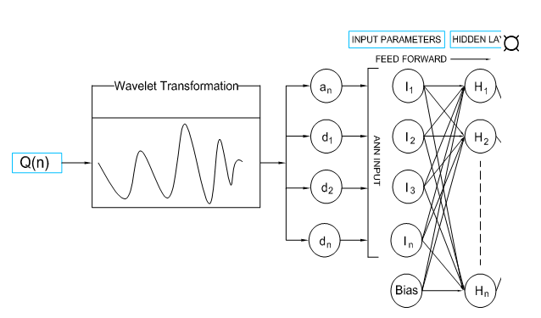

**Fig. 2** Sample Diagram

This test is found to be an excellent tool for trend detection without being affected by outliers. Eq. 1 gives MK test for Z statistic.

|  |  |
| --- | --- |
| $Z=\left\{\begin{aligned}\frac{S-1}{\sqrt{Var\left(S\right)}}, S>0 \\ 0, S=0 \\ \frac{S+1}{\sqrt{Var\left(S\right)}}, S<0\end{aligned}\right.$ (1) | (1) |

**Results**

The findings of research come will be mentioned under this section.

**Conclusions**

A conclusion may review the main points of the conclusion. A conclusion might elaborate on the importance of the work or suggest applications and extensions paper, do not replicate the abstract as the conclusion.

**Acknowledgements**

This work was jointly funded by the German Academic Exchange Service (DAAD) and Higher Education Commission (HEC) of Pakistan. Hydrological data was provided by the Water and Power Development Authority, Pakistan and Dasu Hydropower Consultants. Their help is greatly appreciated.

**References**

Peshawar University, 1970. "The sediment load and measurements for their control in rivers of West Pakistan." Department of Water Resources, Peshawar.

Ali, K. F., 2009. "Construction of Sediment Budgets in Large Scale Drainage Basins: The case of the upper Indus River." PhD thesis, Department of Geography and Planning, University of Saskatchewan, Saskatoon.

Azim, F., Shakir, A. S. and Kanwal, A., 2016. "Impact of climate change on sediment yield for Naran watershed, Pakistan." *Int. J. Sediment. Res.*

Böhner, J. and Lucarini, V., 2015. "Prevailing climatic trends and runoff response from Hindukush-Karakoram-Himalaya, upper Indus basin." *arXiv preprint arXiv:1503.06708*.

Collins, D. N., 1996. "Sediment transport from glacierized basins in the Karakoram mountains, Erosion and sediment yield: Global and regional perspectives " *IAHS*(236).

Dasu Hydropower Consultants, 2013. "Detailed Engineering Design Report, Part A; Engineering Design." 7.

Fletcher, D. and Goss, E., 1993. "Forecasting with neural networks: an application using bankruptcy data." *Information & Management*, 24(3), 159-167.

Gibbons, R. D., Bhaumik, D. K. and Aryal, S., 2009. *Statistical Methods for Groundwater Monitoring: Second Edition*.

Gilbert, R. O., 1987. *Statistical methods for environmental pollution monitoring*, John Wiley & Sons.

Haykin, S., 1999. "Multilayer perceptrons." *Neural networks: a comprehensive foundation*, 2, 156-255.

Holeman, J. N., 1968. "The sediment yield of major rivers of the world." *Water Resour. Res.*, 4(4), 737-.

Hussain, M., Nadya, S., Yusof, K. and Mustafa, M., 2017. "Potential impact of climate change on river inflows to the Batang Ai hydro plant,." *The International Journal on Hydropower & Dams*(01), 44-48.

Kendall, M., 1975. "Rank Correlation Methods (4th edn.) Charles Griffin." *San Francisco, CA*, 8.

Lowe, J. and Fox, I., "Sedimentation in Tarbela reservoir." *Proc., Commission Internationale des Grandes Barrages. Quatorzieme Congres des Grands Barrages, Rio de Janeiro*.

Mann, H., 1945. "Nonparametric tests against trend." *Econmetrica*, 13(3), 245-259.

Meybeck, M., 1976. "Total mineral dissolved transport by world major rivers/Transport en sels dissous des plus grands fleuves mondiaux." *Hydrolog. Sci. J.*, 21(2), 265-284.

Milliman, J., Quraishee, G. and Beg, M., 1984. "Sediment discharge from the Indus River to the ocean: past, present and future." *Marine Geology and Oceanography of Arabian Sea and Coastal Pakistan*, 65-70.

Sen, P. K., 1968. "Estimates of the regression coefficient based on Kendall's tau." *J. Am. Stat. Assoc.*, 63(324), 1379-1389.

Shoaib, M., Shamseldin, A. Y., Melville, B. W. and Khan, M. M., 2016. "Hybrid Wavelet Neural Network Approach." *Artificial Neural Network Modelling*, Springer, 127-143.

Summerfield, M. A. and Hulton, N. J., 1994. "Natural controls of fluvial denudation rates in major world drainage basins." *J. Geophys. Res-Sol. EA.*, 99(B7), 13871-13883.

Zhang, Q., Xu, C.-y., Becker, S. and Jiang, T., 2006. "Sediment and runoff changes in the Yangtze River basin during past 50 years." *J. Hydrol.*, 331(3), 511-523.